**Building HTML Pages**

For this project create four HTML files namely

* about.html
* base.html
* index6.html
* info.html

and save them in templates folder

download the HTML files from the given link in the prerequisites section.

Let’s see how our home.html page looks like:

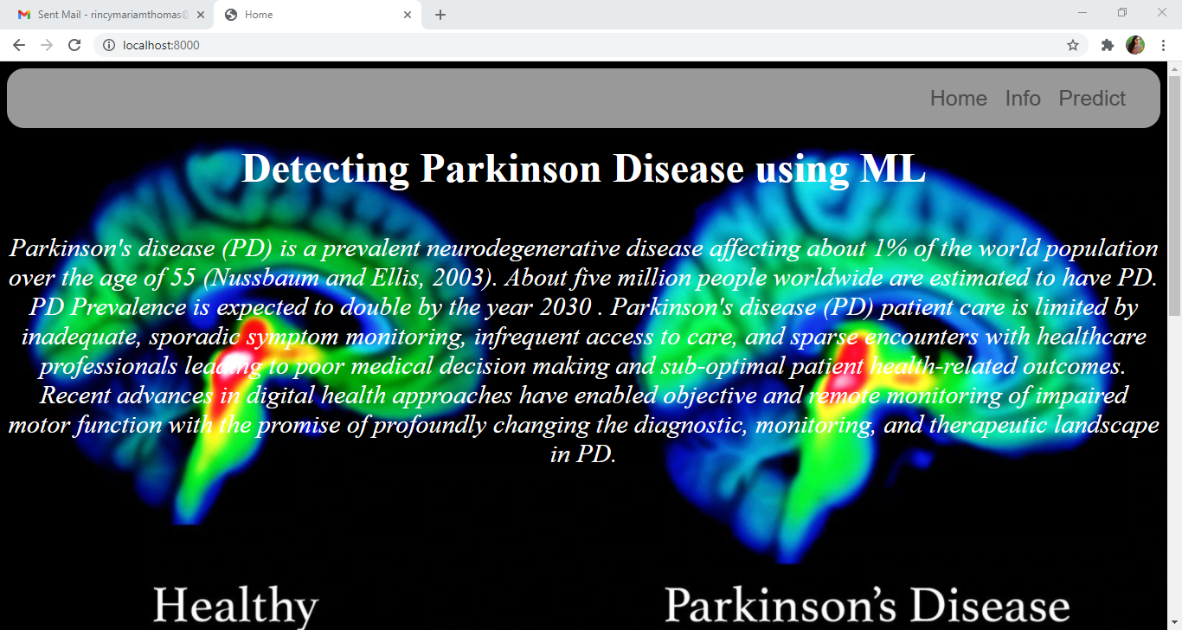

Now when you click on info button from the top right corner you will be redirected to info.html

Let's look at how our info.html file looks like:

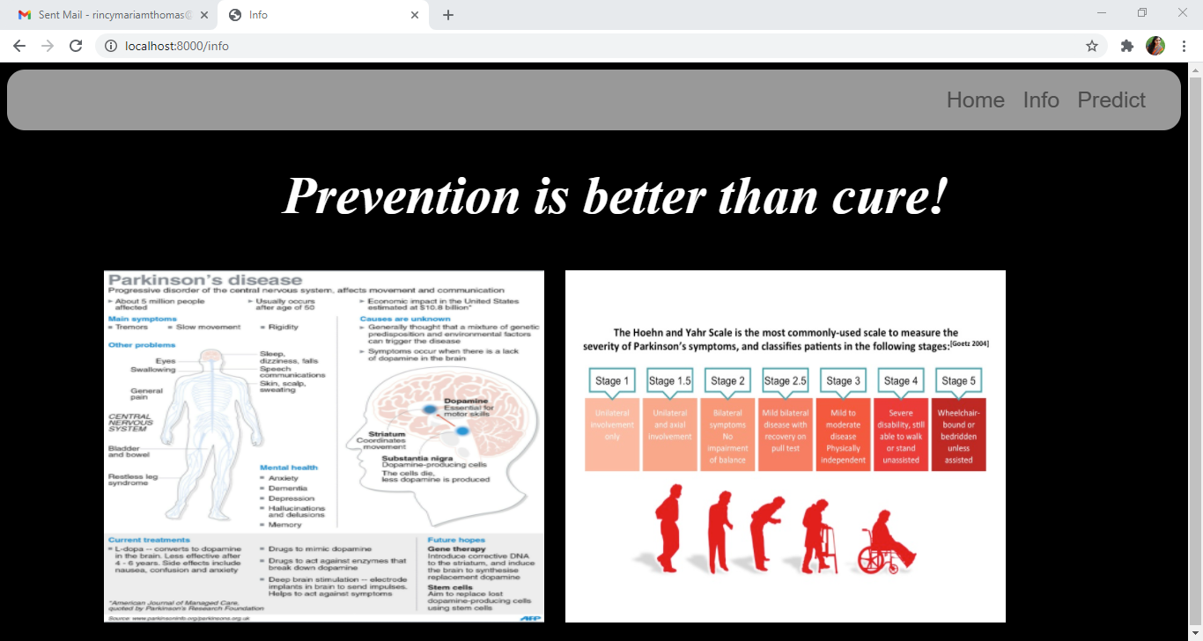

Now when you click on predict button from the top right corner you will be redirected to index6.html

Let's look at how our index6.html file looks like:

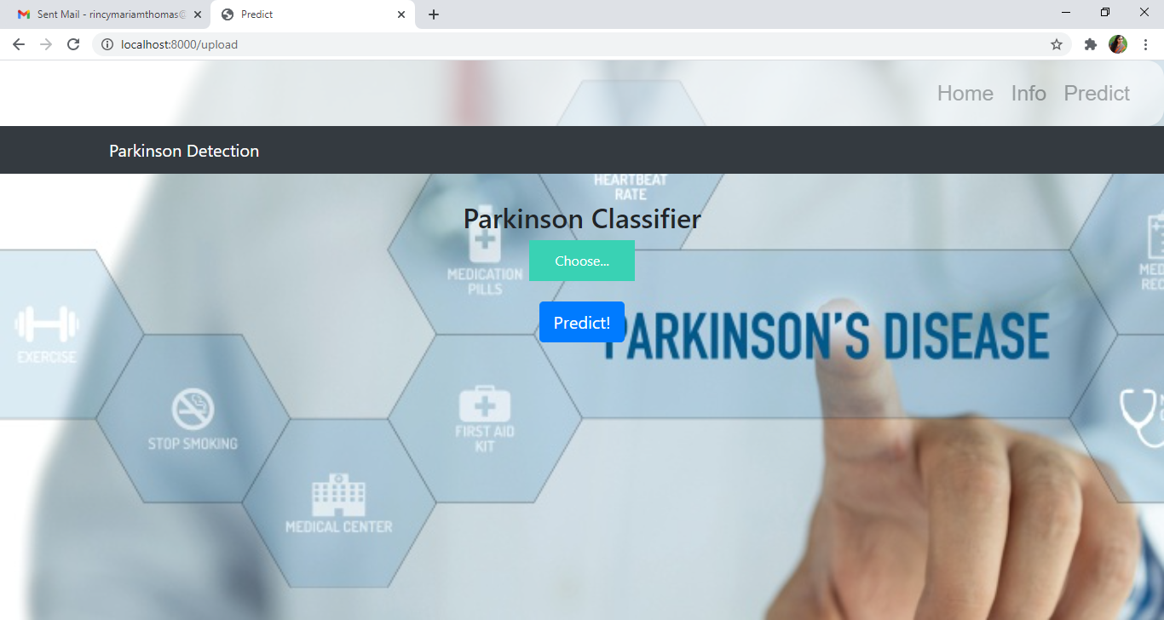

Now from this page give the input image and see the predicted output on the UI